**04: Install eksctl CLI**

**Installing eksctl on Mac**

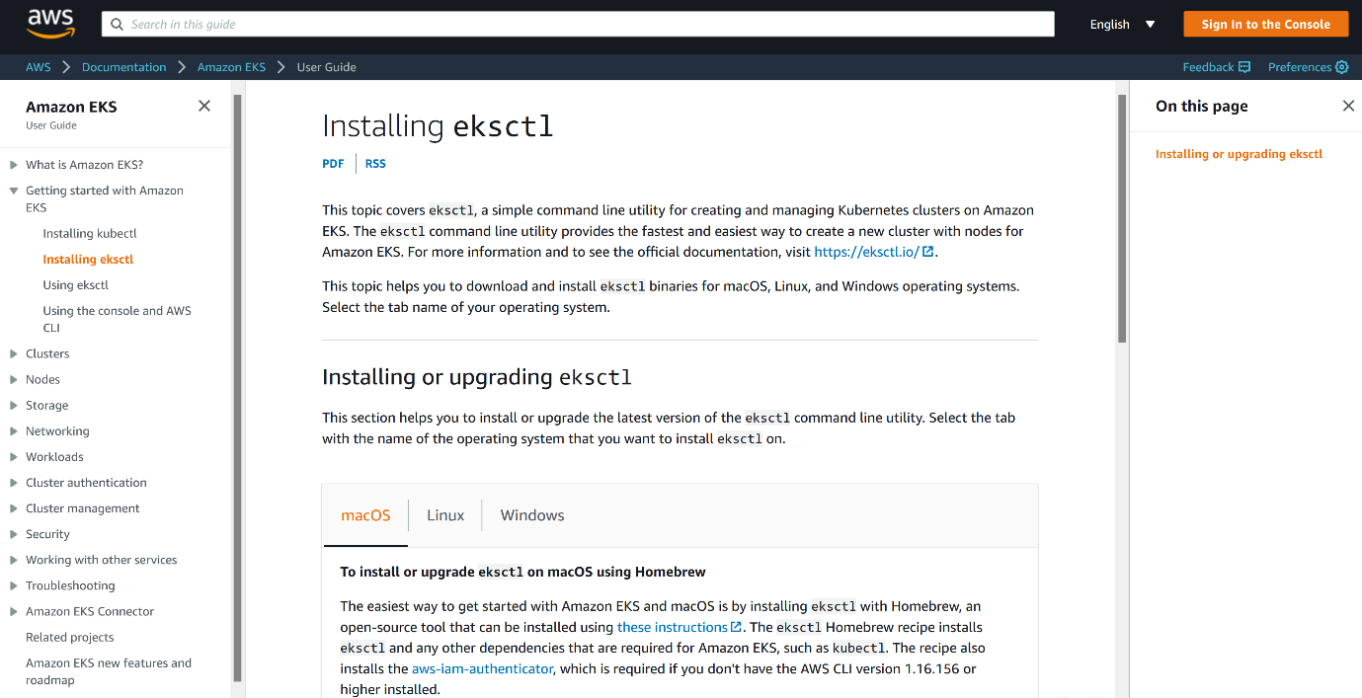

--- based on operating system you have, you can download the eksctl version of your operating system.

**# Install Homebrew on MacOs**

--- **/bin/bash -c "$(curl -fsSL https://raw.githubusercontent.com/Homebrew/install/master/install.sh)"**

**# Install the Weaveworks Homebrew tap**.

--- **brew tap weaveworks/tap**

**# Install the Weaveworks Homebrew tap.**

--- **brew install weaveworks/tap/eksctl**

**# Verify eksctl version**

--- **eksctl version**

**eksctl on windows or linux**

--- **note** - For windows and linux OS, you can refer below documentation link.

--- **Reference**: https://docs.aws.amazon.com/eks/latest/userguide/eksctl.html#installing-eksctl

--- **References**: https://docs.aws.amazon.com/eks/latest/userguide/getting-started-eksctl.html